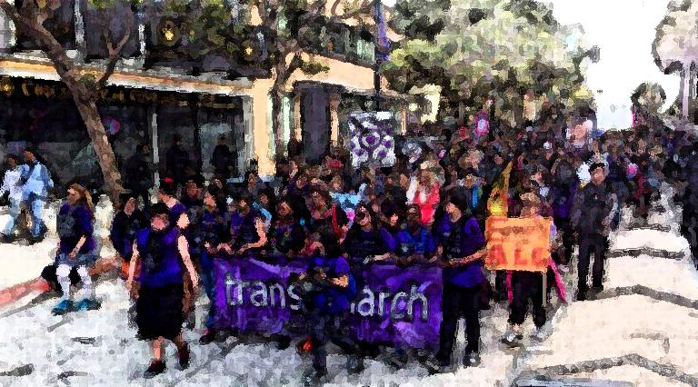
2017 Trans March Sponsor Packet

The Trans March is San Francisco’s premier annual transgender PRIDE event. The mission of the San Francisco Trans March is to inspire all trans and gender non-conforming people to realize a world where we are safe, loved, and empowered. We strive to create a space for our diverse communities to unite and achieve the social justice and equality that each of us deserves. Each year the march has grown in size and reputation allowing us to reach thousands of community members in the Bay Area and beyond.

The fourteenth annual Trans March will be held on June 23, 2017. The day will feature a Youth and Elders Brunch, Trans March stage program with speakers and performances, a resource fair and a community march from Dolores Park to downtown San Francisco.

A Trans March of this magnitude is not possible without sponsorship and contributions from the larger community. We hope to count your business or organization among our supporters for the 2017 Trans March.

For full sponsorship benefits, please return the sponsorship form before or on Friday, May 20, 2017. If you have questions about sponsorships or for further information about the Trans March, please email info@transmarch.org.

In this Packet:

- Trans March 2017 Sponsor Form
- Trans March 2017 Sponsorship Benefits Information

2017 Trans March Sponsor/Order Form

Company/Organization____________________________________________________
(Please print as you would like it to be listed on Trans March materials)

Contact Person: __________________________________________________________

Phone (Day): (___) ______________E-mail ________________________@______.____

Address: ___________________ City: _________________ State: ___ Zip:___________

Please check the level of sponsorship:

____ PLATINUM ____ GOLD ____ SILVER ____ JEWEL ____ BRONZE

By signing this contract, we agree to sponsor Trans March 2017. We have also indicated our level of commitment above.

Signature:_______________________________ Date: ____________________

Please fill out this form and either mail or e-mail to:

Trans March SF
3543 18th Street #4
San Francisco, CA 94110

info@transmarch.org

PAYMENT: Make checks payable to “Queer Cultural Center”, and indicate that payment is for “ Trans March 2017” on Memo line. Mail checks to:

Trans March SF
3543 18th Street #4
San Francisco, CA 94110

Please direct all questions to info@transmarch .org.

Thank you for your tax-deductable contribution!

SPONSORSHIP PACKAGE | Non- Profit Rate
PLATINUM  ● Name/logo featured as Presenting Sponsor in all media, invitations, advertising, fliers, posters, emails, program, and press releases (sponsorship form must be received by May 20, 2017 for print materials).  ● Name/logo on Trans March website home page for 1 year.  ● Recognition at event by performance stage MCs.  ● Space (10’ x 10’) at the Resource Fair to table at the Trans March (table and booth not provided). There limited spaces at the Resource Fair, not everyone maybe accommodated).  ● Four (4) Trans March shirts. | $1,000.00
GOLD  ● Logo featured in all Trans March related media, invitations, advertising, fliers, posters, and emails (sponsorship form must be received by May 20, 2017 for print materials).  ● Name/logo on Trans March website home page for 1 year.  ● Recognition at event by performance stage MCs.  ● Space (10’ x 10’) at the Resource Fair to table at the Trans March (table and booth not provided). There limited spaces at the Resource Fair, not everyone maybe accommodated).  ● Two (2) Trans March shirts. | $ 500.00  (organizations with a budget of $100,000 or less)
SILVER  ● Name listed in all Trans March related media, invitations, advertising, fliers, posters, and emails (sponsorship form must be received by May 20, 2017 for print materials).  ● Name/logo on Trans March website home page for 1 year.  ● Space (10’ x 10’) at the Resource Fair to table at the Trans March (table and booth not provided). There limited spaces at the Resource Fair, not everyone maybe accommodated).  ● Recognition at event by performance stage MCs. | $ 250.00  (organizations with a budget of $50,000 or less)
BRONZE and “in kind” donations  ● Logo placed on the outside of highly visible Porto- Potties the day of the Trans March  ● Recognition at event by performance stage MCs.  ● Space (10’ x 10’) at the Resource Fair to table at the Trans March (table and booth not provided). There limited spaces at the Resource Fair, not everyone maybe accommodated).  ● Name/logo on Trans March website home page for 1 year. | $ 150.00 (organizations with a budget of $10,000 or less)
JEWEL $10 - $99  ● Name listed on the Trans March website | $ 10.00- $99.00
*Customized sponsorship packages are available, within reason and subject to the approval of Trans March. Please send inquiries and requests to info@transmarch.org.

